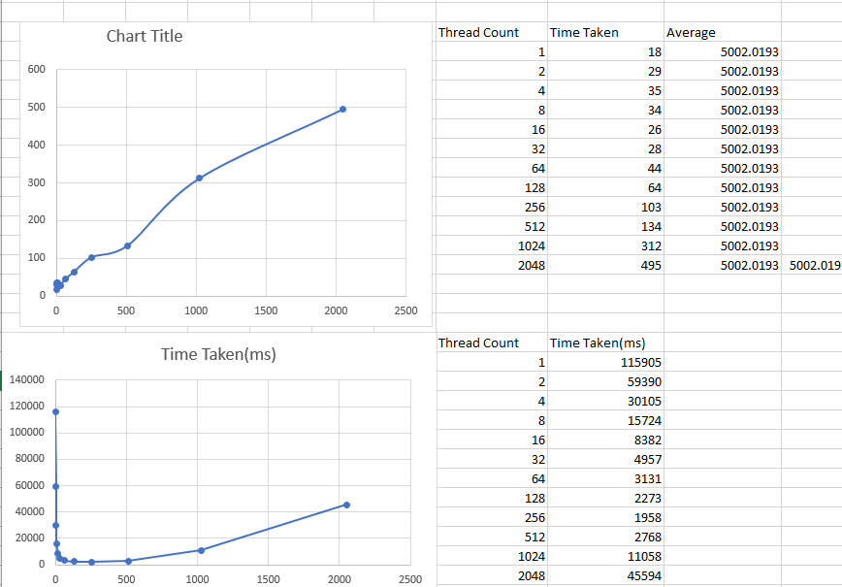

Week 3 Lab2

Task 1: Find Mean of an Array using Multi-thread in Java (15 marks)

Comment: Execution time increases as number of thread increases. Due to overhead, thread creation makes the execution time slower.

Global average = 5002.0193

Task 2: Find Median of an Array using Multi-thread in Java (25 marks)

Comment: Execution time decreases as number of threads increases until 256 threads. From this point onwards, execution time increases as number of threads increases.